Characterization Principles
Introduction
Thin film characterization is a crucial aspect of materials science and engineering, playing a significant role in various industries and research fields. Thin films are thin layers of material deposited onto a substrate, and they are utilized in a wide range of applications, including electronics, optics, coatings, and more. Characterizing these thin films is essential for several reasons:

Quality Control: Thin film characterization helps ensure the quality and consistency of thin films in terms of thickness, composition, and other properties. This is vital for manufacturing processes, especially in industries such as microelectronics and optoelectronics.
Performance Optimization: Understanding the properties of thin films allows researchers and engineers to optimize their performance for specific applications. This includes tailoring the thickness, refractive index, and other characteristics to achieve desired functionality.
Device Fabrication: Many electronic and optical devices rely on thin films. Characterization is crucial during the fabrication process to ensure that the thin films meet the required specifications for the devices to function as intended
Understanding Physical Properties: Thin film characterization provides insights into the physical and chemical properties of materials at the nanoscale. This is essential for advancing our understanding of material behavior and for developing new materials with enhanced properties.
Research and Development: In research, thin film characterization helps scientists explore new materials and develop innovative technologies. It contributes to advancements in areas such as nanotechnology, sensors, solar cells, and more.
Diagnostic Tool: Characterization techniques, such as spectroscopy and imaging, serve as diagnostic tools to identify defects, impurities, or other issues within thin films. This information is crucial for troubleshooting and improving manufacturing processes.
Optical and Electronic Properties: Thin films often exhibit unique optical and electronic properties that differ from bulk materials. Characterization helps in studying these properties, enabling the design of devices with specific functionalities.
Advancements in Nanotechnology: As nanotechnology continues to evolve, thin film characterization becomes even more critical. The ability to precisely analyze and control thin film properties is essential for developing nanoscale devices and structures.
Common techniques for thin film characterization include ellipsometry, X-ray diffraction, atomic force microscopy, scanning electron microscopy, and various spectroscopic methods.
In summary, thin film characterization is indispensable for ensuring the quality, performance, and functionality of thin films, contributing to advancements in technology and materials science.

Structural studies
Here, the methods used to look into the morphological and structural characteristics of thin films have been described. These methods include scanning electron microscopy (SEM) for surface morphological characterization and X-ray diffraction (XRD) for structural characterization. The structural studies of thin film technology involve examining and understanding the arrangement, composition, and morphology of thin films at the atomic and nanoscale levels.
These studies are crucial for optimizing the properties of thin films for specific applications. Structural characterization techniques are essential for tailoring thin film properties to meet specific application requirements. Researchers use the information obtained from these studies to optimize deposition processes, understand growth mechanisms, and design thin films with desired structural characteristics for applications in electronics, optics, sensors, and more.

XRD
The most accurate method for determining the crystal structure of solids is X-ray diffraction, which typically doesn't call for extensive sample preparation and is basically nondestructive [1]. Utilizing X-ray diffraction, thin surface films up to 1000 thick can be examined. RHEED, or reflection high energy electron diffraction, can be used to identify thicker films. The Joint Committee of Powder Diffraction Standards (JCPDS), which discloses the presence of several crystallographic phases in the film, their relative abundance, the lattice parameters, and the preferred orientations, can be used to compare the XRD-derived diffracted patterns.
The ability to distinguish between single crystals and polycrystalline deposits with random distributions of orientation with respect to the coating plane is necessary. Knowing the direction of a single crystal coating in regard to the substrate is crucial. Whether the sample is a single crystal or polycrystals [1], either with a random distribution of orientations or with a preferential orientation with respect to the film plane, X-ray diffraction is an appropriate method for figuring out the crystal structure of any unknown materials.
Peaks of dispersed intensity that correspond to the following circumstances are seen when x-rays are scattered from a crystal lattice:
I. The incidence angle = the scattering angle.
II. The difference in path length corresponds to an integer number of wavelengths.
When crystalline substances are subjected to X-rays, interference between the waves scattered by the atoms happens. Depending on how the waves overlap, interference can take one of two different forms. When the waves are travelling in phase with one another, as schematically depicted in Figure 2.15, constructive interference occurs. When the waves are out of phase, destructive interference takes place.
Bragg's Law, which describes the relationship between the angle at which an X-ray beam of a specific wavelength diffracts from a crystalline surface, was found by Sir William H. Bragg and Sir W. Lawrence Bragg: Where dhkl is the distance between the crystal plane for the Wurtzite structure ZnO unit cell, it is calculated using the following relation:
$\frac{1}{d_{hkl}^{2}}= \frac{4(h^{2}+hk+k^{2})}{3a^{2}}+\frac{1}{c^{2}}$ … … … … … (2.3)
a, c are lattice constants. θ is the X-ray incident angle; λ is the wavelength of the X-ray and n is a positive integer. Bragg’s law also suggests that the diffraction is only possible when λ<2d.

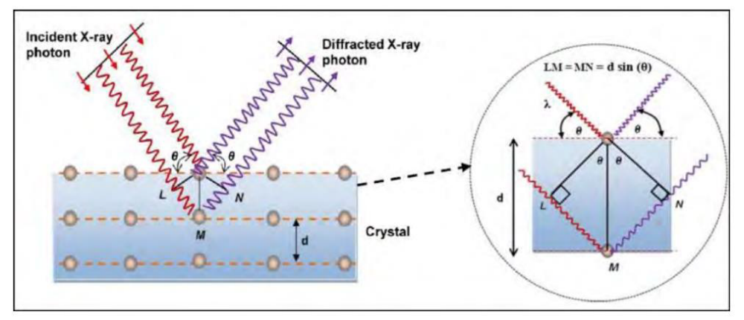
Figure 2.15: X-ray diffraction from Bragg planes. Reproduced from ref. [2]

It is feasible to determine the crystallite size of the film by estimating the width of the diffraction line. The Scherrer equation, often known as the X-ay line broadening, is frequently used to calculate crystallite size and is denoted as follows:
D = kλ/ βcosθ

Where is the full width at half maximum (FWHM) of the peak in radians, is the angle of incidence in degrees, and is the wavelength of the radiation utilized as the primary beam of CuK (= 1.54178 ). K is the dimensionless constant, typically having a value of 0.9. The strain () is calculated using the relations below:

$ε=\frac{βcosθ}{4}$ …. …. …. …. (2.4)
The dislocation density () is calculated from the following relation using the straightforward Williamson and Smallman method. It is defined as the length of the dislocation lines per unit volume of the crystal.
$δ=\frac{1}{D^{2}}$ …. …. …. …. (2.4)
By using an X-ray diffractometer (Model: BRUKAR D8 ADVANCE), the structural characterization of the deposited films was performed, as shown in Figure 2.16

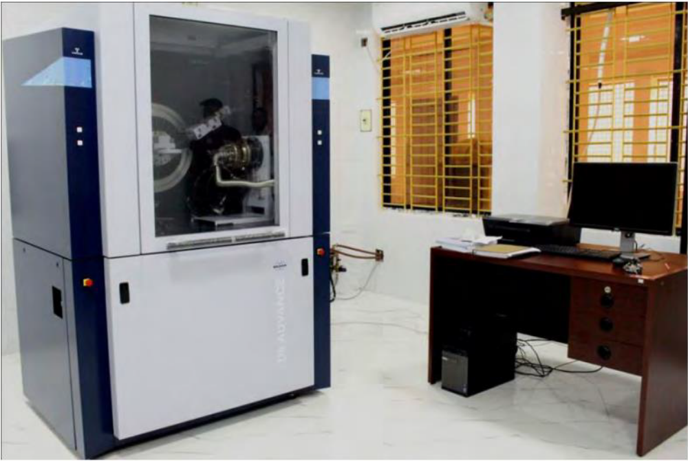

Figure 2.16: Photograph of X-ray diffractometer (Model: BRUKAR D8 ADVANCE)

SEM
One of the best methods for examining the surface morphology of thin films is scanning electron microscopy, or SEM. The specimen is excited using a high energy electron beam, which causes many interactions with the atoms of the target material. A SEM may collect a variety of signals, including secondary electrons, recognizable X-rays, and back scattered electrons. In order to create an image, the signals are gathered and examined as indicated in Figure. The signals convey information about the surface topology, chemistry, and crystallography of the materials.

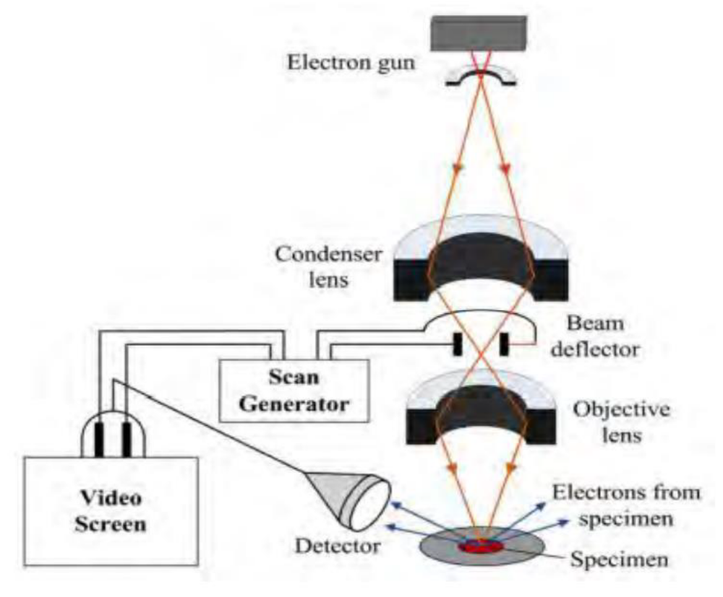
Figure 2.17: Schematic diagram of the SEM working principle. Reproduced from ref. [3].

These signals in a SEM are produced by interactions within the sample close to the surface as well as by the primary beam impinging on the sample [3]. A schematic diagram of the SEM's operation is shown in Figure 2.17. In its principal use mode, secondary electron imaging, the SEM can provide high resolution images of a sample surface.
Additionally, it demonstrates the capability of secondary electron imaging, which is its major application, to generate high resolution images of a sample surface. SEM images have a significant depth of field as a result of the way they are produced, giving them a distinctive three-dimensional appearance that is helpful for comprehending the surface structure of a material.
The SEM's most popular imaging mode for specimens has a large depth of field and a variety of magnifications. When the primary beam induces the ejection of inner shell electrons from the sample, characteristic X rays are released, which can be utilized to determine the elemental makeup of the sample.
Backscattered electrons from the sample can be utilized alone to create an image or in combination with the distinctive X-rays to provide atomic number contrast hints about the sample's elemental makeup.

Optical Studies
Optical studies play a crucial role in characterizing thin films due to their unique ability to provide valuable information about the film's properties, composition, thickness, and more. Here are some key aspects of the significance of optical studies in thin films characterization:

Thickness Measurement:
Optical methods, such as ellipsometry and reflectometry, are widely used to determine the thickness of thin films. By analyzing the interference patterns or changes in reflection or transmission, researchers can precisely measure the thickness of the film.
Optical Constants:
The refractive index (n) and extinction coefficient (k) are important optical constants that describe how light interacts with a material. Optical studies help in determining these constants, providing insights into the film's composition, density, and electronic structure.

Film Composition and Homogeneity:
Spectroscopic techniques, including UV-Visible and infrared spectroscopy, can reveal information about the composition of thin films. Changes in absorption spectra can indicate the presence of specific materials or chemical bonds. Homogeneity and uniformity across the film can be assessed through optical microscopy.

Surface Roughness:
Optical methods are sensitive to surface features, allowing researchers to evaluate the roughness of thin films. Interference effects can be influenced by surface irregularities, providing details about the film's topography.

Optical Bandgap and Electronic Structure:
The absorption spectrum of a thin film can provide information about its electronic structure, including the bandgap. This is crucial for understanding the film's optical and electronic properties, which are vital in various applications, such as semiconductors and photovoltaics.

Real-time Monitoring:
Optical techniques often allow for real-time, in-situ monitoring of thin film deposition processes. This is valuable for ensuring the desired film properties and adjusting deposition parameters as needed.

Optical Devices and Applications:
Thin films are integral to the development of optical devices such as sensors, waveguides, anti-reflective coatings, and more. Understanding and controlling the optical properties of thin films are critical for optimizing the performance of these devices.
Quality Control:
Optical characterization provides a non-destructive and efficient means of quality control for thin films in industrial applications. It helps ensure that films meet specific requirements and standards.
In summary, optical studies offer a wealth of information for characterizing thin films, making them an indispensable tool in materials science, device fabrication, and various technological applications.
In this section the characterization techniques that were employed to investigate the optical properties of the thin films has been discussed.

UV-visible spectroscopy
Spectroscopy is generally understood to be a field of research that examines how light and matter interact. It is the scientific measurement of a material's transmission or reflection characteristics in relation to wavelength . UV-Visible (UV-Vis) spectroscopy is a sort of absorption spectroscopy in which a molecule absorbs light in the ultra-violet range (200-400 nm), which causes the electrons to be excited out of their ground state and into a higher energy state. The energy difference between the ground state and higher energy states is equal to the energy of the UV radiation that is absorbed. The intensity of light passing through a sample (I) is measured by a UV-Vis spectrophotometer, and it is compared to the intensity of light preceding the sample (I0).
Figure 2.18 depicts a schematic diagram of the UV-Vis spectrophotometer's operating system. The transmittance, also known as the ratio (I/I0), is frequently given as a percentage (%T) [4]. The transmittance is the foundation for the absorbance A. Reflectance measurements can also be made using the UV-visible spectrophotometer. Here, the spectrophotometer measures the amount of light reflected from the sample (I) and contrasts it with the amount of light reflected from the reference material (I0). Reflectance is the ratio (I/I0), and it is frequently stated as a percentage (%R). A reliable method to ascertain the shape of the absorption edge is to measure the transmission or reflection of a sample.
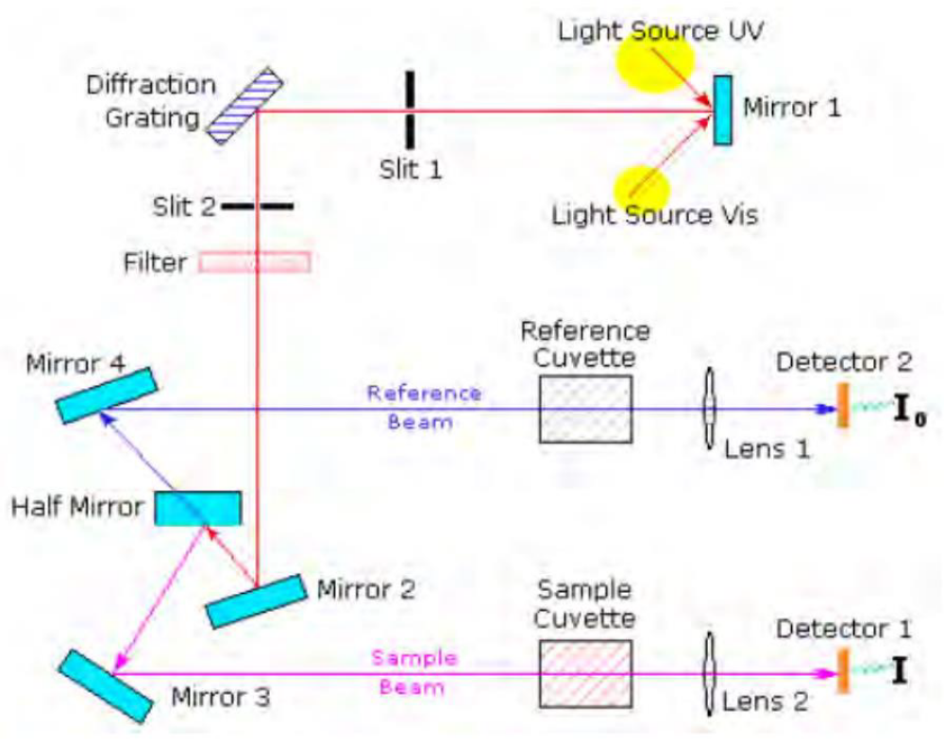
The absorption edge and energy band gap (Eg) can be determined from the transmission measurement. When a radiation is incident on a thin film material with energy equal or greater than that of the band gap, absorption of the photons can take place and electrons can be raised in energy from the valence band to the conduction band, creating electron-hole pairs. The material can transmit the photons having energy less than the band gap of the semiconductor, as the energy is insufficient to create an electron hole pair.

Figure 2.18: A scheme of UV-Vis spectrophotometer operating mechanism. Reproduced from ref. [4].
The ability of a material to absorb photons of a given wavelength is measured quantitatively by the optical absorption coefficient (α), measured as: α = 2.303A/d, where d is film thickness and A is absorbance.
The optical absorption coefficient and energy band gap (Eg) relation is known as Tauc’s relation [70]; can be written for direct band gap material as:
𝛼ℎ𝜐 = ${(hυ – E_{g})}^{1/2}$ …. …. …. …. (2.6)

Other parameters such as film thickness (d), optical conductivity etc. also can be measured from the parameters and results found above. Film thickness can be measured from optical reflectance data by Swanepoel’s method using the following relation:
d = $\frac{λ1λ2}{2(n1λ2+n2λ1)}$ …. …. …. …. (2.7)

Where 𝑛1 and 𝑛2 are the refractive indices at two adjacent reflectance maxima (or minima) at the wavelength λ1 and λ2, respectively.

FTIR
One of the most effective analytical techniques for determining the presence of specific functional groups in a molecule and spotting specific impurities in inorganic and organic substances is infrared spectroscopy (IR). The molecular makeup of the materials as well as the functional groups on surfaces and adsorbents can be determined from the IR analysis. The absorption peaks of an infrared spectrum, which correspond to the frequency of vibration of the bonds between the atoms that make up a sample, are like the fingerprints of the sample. The basis for infrared spectroscopy is the absorption of IR light, which causes the sample to change from one vibrational state to another with a higher energy. As a result, the infrared spectrum is made up of a collection of absorption bands, the intensity and frequency of which reveal details about the structure and bonding of molecules.
The spectrum is acquired as an inverse Fourier-Transform of the interferogram by FTIR instruments, which use interferometer techniques to capture spectral data [53]. A beam splitter in the interferometer divides the radiation that the light source emits into two parts, to put it more fully. Each beam is reflected back to the beam splitter by the fixed and mobile mirrors, where they recombine into a single beam that strikes the detector. When the moving mirror is moved, the two beams can merge constructively or destructively, depending on the optical path difference. All of the sample's infrared data is contained in the interferogram that is detected as the combined beam passes through the sample.
The infrared spectrum is obtained from the interferogram by the mathematical process of Fourier transformation. This operating principle has been shown schematically in following the Figure.

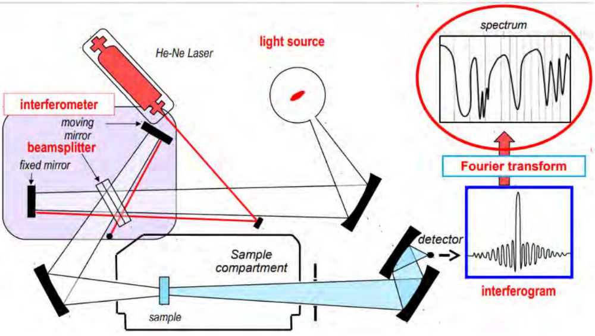

Figure 2.19: A schematic of FTIR spectroscopy. Reproduced from ref. [5].

